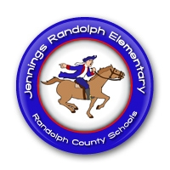
JRES PRE-K
Patriot Newsletter
January 23, 2017
Announcements
- We are having a pep rally today to support our JRES basketball teams & cheerleaders!
- I will be scheduling parent meetings for the second evaluation period! Keep an eye out for dates & times!

This Week’s Activities
We will be doing an experiment to see how blubber helps animals stay warm!
We’re putting something different in our water table-cotton balls!
We’ll use those cotton balls & see how far we can move them using only straws!
Mixing shaving cream with glue makes a puffy paint that looks like snow!

Reminders
- JRES is having a “Winter Ready” drive to help those in need! **You can donate any item on any day! We appreciate your generosity!
-Monday-canned goods (veggies, fruits, & meats)
-Tuesday-packaged items (stuffing, mac& cheese, cereal)
-Wednesday-drinks (coffee, juice, formula, non-glass items)
-Thursday-personal care (soap, shampoo, dental)
-Friday- winter wear (gloves, hats, gently used coats & boots)

Do You Have Questions? Contact Me!
smware@k12.wv.us
304-636-9181

