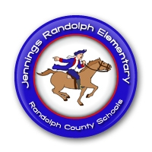
JRES PRE-K
Patriot Newsletter
October 31, 2016
Announcements
- Tuesday, Nov. 8th & Friday, Nov. 11th are No School Days for Election Day & Veteran’s Day
- We will have a Veteran’s Day Assembly on Thurs., Nov. 10th at 1:00pm. All veterans & family are invited to attend!

This Week’s Activities
We will be learning about the alphabet stamps & ink pads that we are adding to our writing area!
We will see what we can make using paper clips & shoe strings!
We will create artistic collages using pumpkin seeds & leaves!
We will play an alphabet train game to practice letter recognition!

Reminders
- Please label all coats & jackets with names or initials!
- If your child is absent, please send in either a doctors excuse or a written excuse from you the next day they are back at school!

Do You Have Questions? Contact Me!
smware@k12.wv.us
304-636-9181

