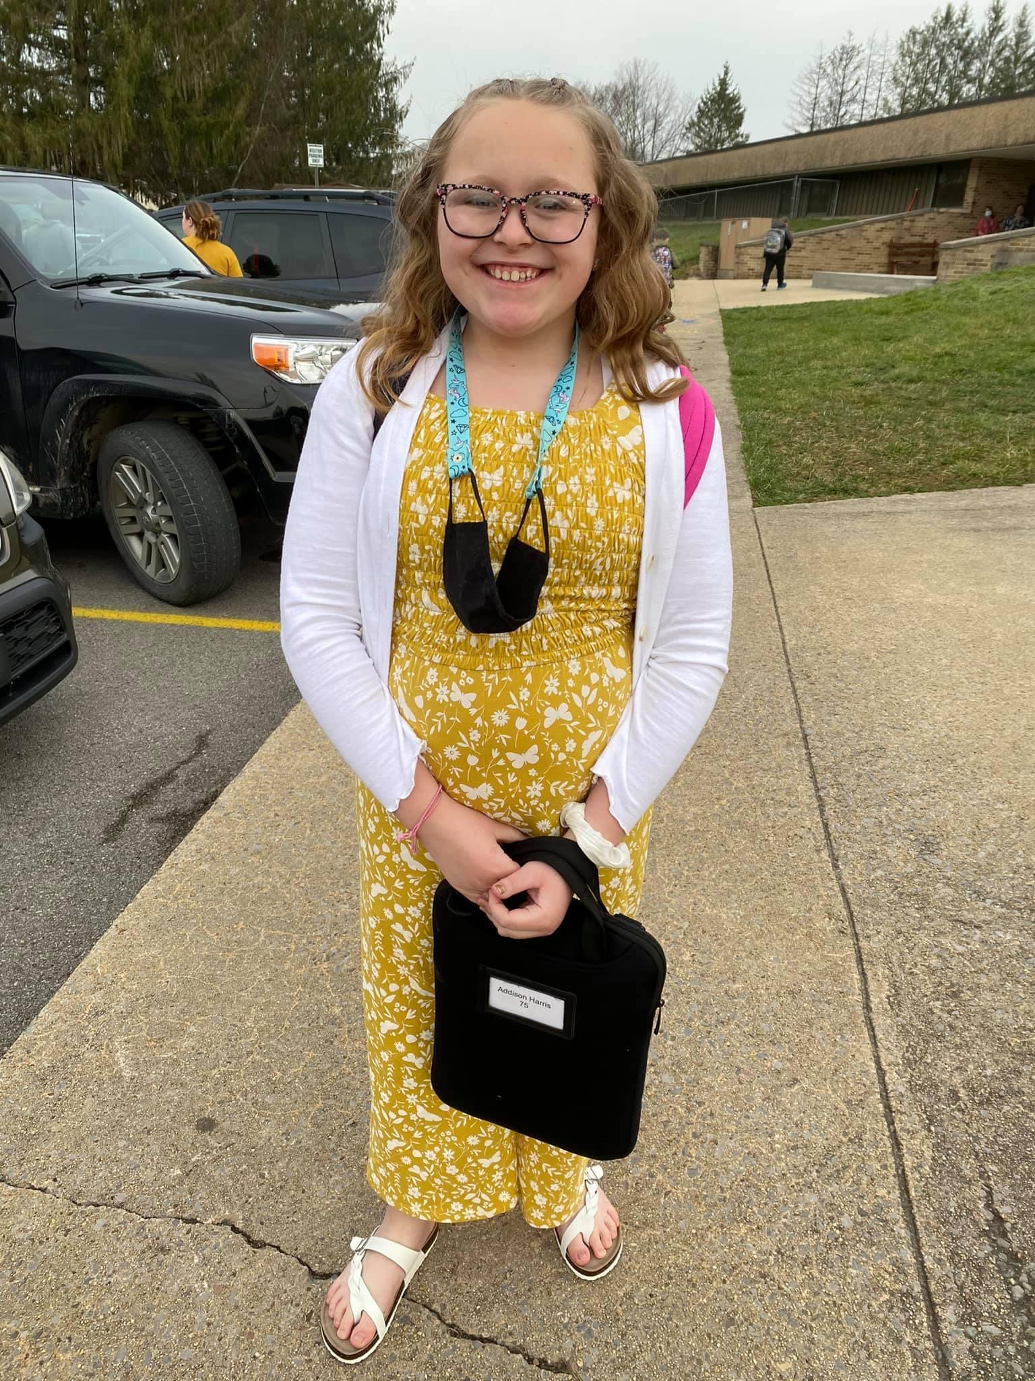 CHROMEBOOKS

Since our schools have many students participating in various summer learning opportunities, Randolph County Schools has decided to allow students to keep their Chromebooks over the summer.
However, if your child is NOT participating in Summer SOLE, you may choose to store the Chromebooks. (5th Graders will need to keep theirs to take on to middle school.)
If a student has lost his/her charger, the cost is $35 for a replacement charger.
If you have an issue with your Chromebook over the summer, please call Julie Burky at the Randolph County Board of Education at 304-636-9150 x 135.

Please complete and return the form below to your child’s teacher. (Reminder: 5th graders will KEEP their Chromebooks and take on to middle school.)
~~~~~~~~~~~~~~~~~~~~~~~~~~~~~ cut here ~~~~~~~~~~~~~~~~~~~~~

Student Name: ________________________________ Current Grade: ____________

_____ My child will keep her/his Chromebook at HOME this summer.

_____ I would like to store my child’s Chromebook at JRES this summer.

____________________________________ Parent Signature ___________ Date

*Please cut off and keep the top portion of this sheet for reference.

