Lunch Schedule  PreK-K – 11:25  1ST – 11:30  2ND – 11:35  3RD – 11:55  4TH – 12:00  5TH – 12:05  Please do not join your child for lunch until after the Forest Festival. We also request you do not join your child for lunch in May or on party days due to schedule changes. | Arrival Time  Our doors open at 8:00. All students should be at school by 8:15.  In the event of a 2-hour delay, doors open at 10:15Do not drop your child off before doors open because there is not adult supervision. | Success Room  Students who have missing work or behaviors to address will visit our Success Room. Also, students who have 5 or more late arrivals or unexcused absences will also attend Success Room. | Jennings Randolph Elementary  School Information A to Z
Car Riders/Parent Pick Up Information:  Car riders should be picked up at 3:10. Please avoid being late as staff have end of the day meetings and trainings. A parent who is late 3 times may be asked to meet with the principal. | End of Day  Please do not pick your child up early unless absolutely necessary. The classroom gets very busy at 3:00. Those needing picked up 3:00 or later will be sent out on the Side Lot with car riders at 3:10 unless a note has been provided in advance. | 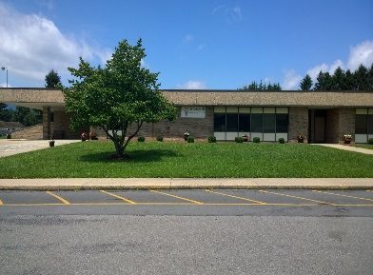 | 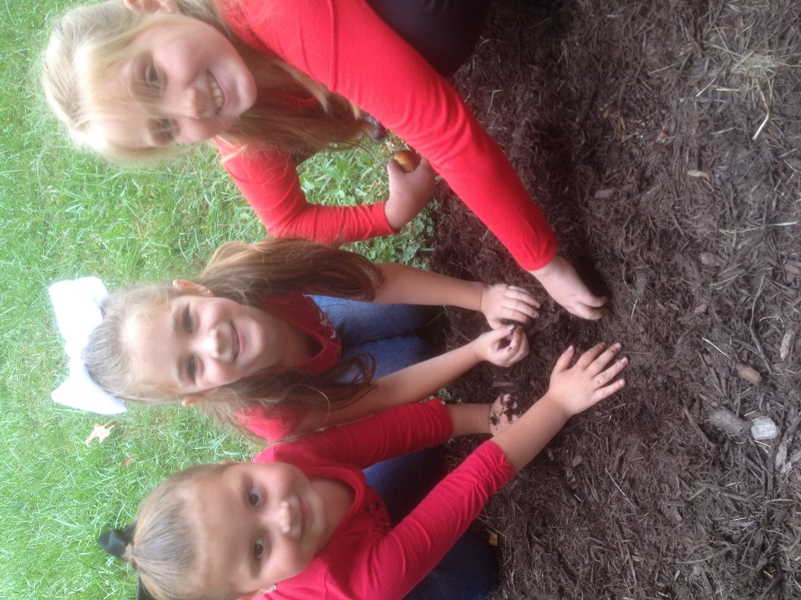  Our goal is to develop lifelong learners by instilling empathy, respect and responsibility through the combined efforts of the school, family and community.
Jennings Randolph

•••
101 Scott Ford Rd.

•••
304-636-9181
•••
304-636-9166 fax
•••
Jenningsrandolph.rand.k12.wv.us

