Create Your Own Musical Instrument!
You are going to have to be creative in the way you approach this activity, objects in your home that you might not typically view as a musical instrument might surprise you!

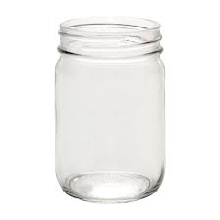
- First find a container, this could be a soup can, tupperware container, toilet paper roll, or even a mason jar.
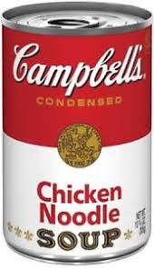
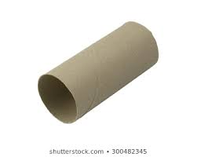
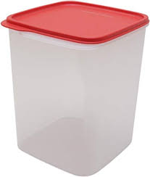

- Next, find a material to fill the container with. It could be anything, noodles, rice, or even marbles. Then fill the container about half-way up.
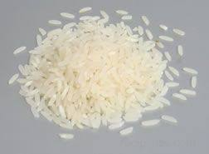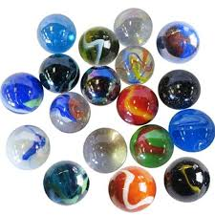
- Find a way to make sure that the ingredients of your container don’t fall out, I recommend using some duct tape.
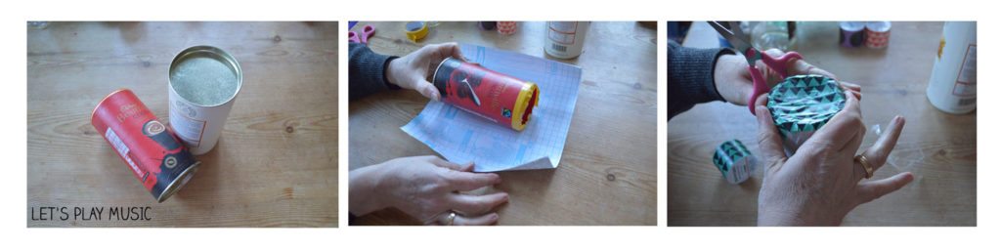
- Lastly, try to play your instrument along with a song on the radio!
Be sure to keep a steady beat the entire time. Test your skills and play along with both a FAST and a SLOW song.

