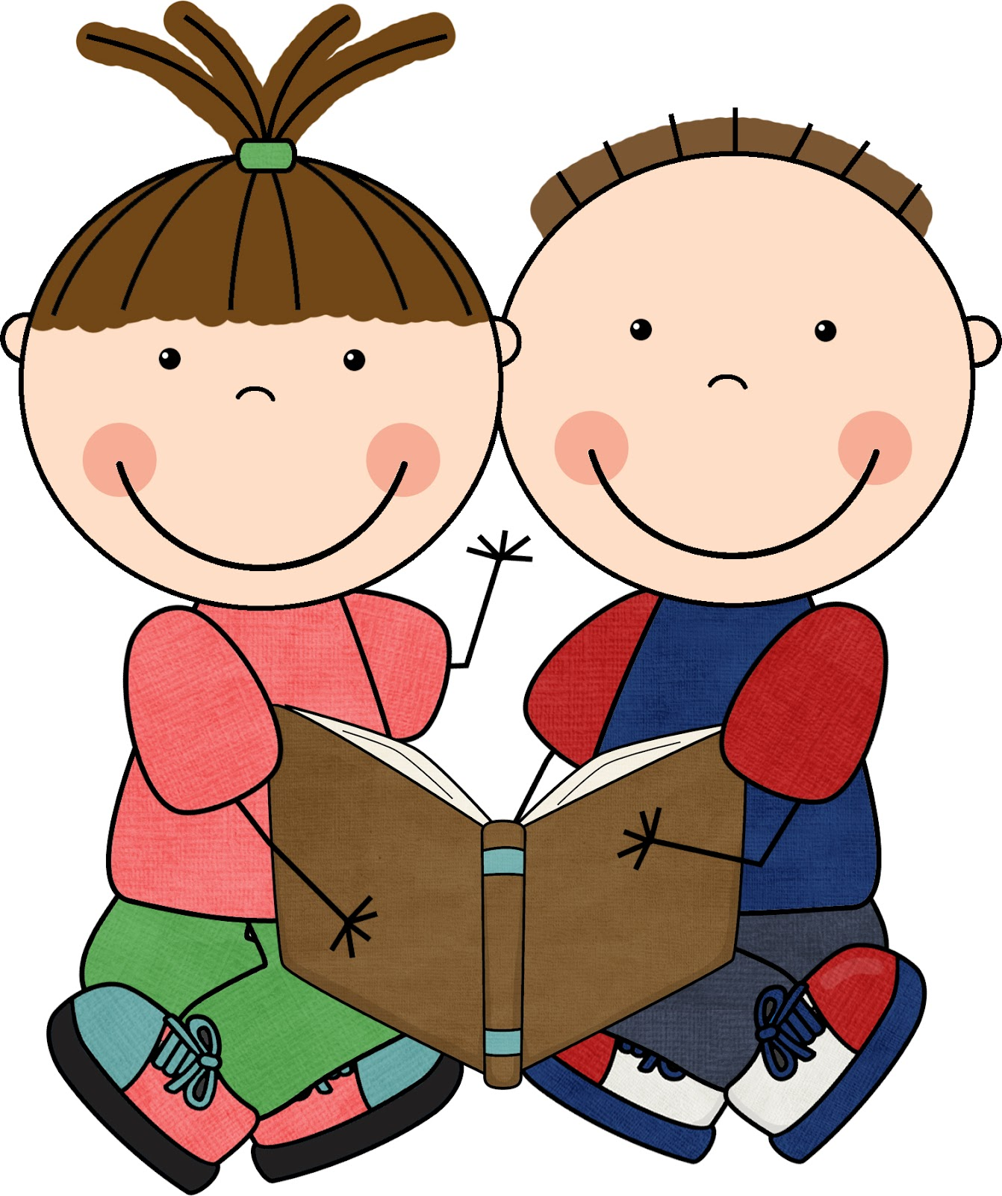
Title I Reading Ideas
Here are some more reading activities that you can do at home.

Write a letter to the author of your book about what you liked in the story. | Draw an illustration of the setting of your book. | Write a book review telling if we should or should not read this story. Share with a family member. | Make a 5-question quiz about your book.
Create a new book cover for your book with an illustration on the front, and a brief summary on the back. | Write a new ending for your book. | Create a bookmark telling what the book is about and why someone should read it. | Read outside in your favorite spot.
Find 5 nouns in your story and illustrate them. | Write a list of 5 questions that you would ask the main character in your story. | Pick your favorite part of a story and act it out. | Write a paragraph about which character is most like YOU and why.
Create and put on a puppet show for a family member about your book. | Choose two stories and tell 3 things that are the same and 3 things that are different. | Use the website wordle.com to create a collage of important words from the story. | Make a commercial selling your book.

