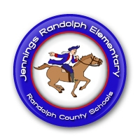
JRES PRE-K
Patriot Newsletter
September 12, 2016
Announcements
- We are excited for our Grandparent Lunch today!
- Tues, Sept. 13th is a 2 Hour Early Dismissal for students!
- School pictures are this Thursday!

This Week’s Activities
We’ll tell stories about animals & make patterns to help us!
We will see what happens when we mix colored paint with white & black paint!
Like the zoo keeper & gorilla in Good Night, Gorilla, we’ll work with flashlights & keys!
We will practice patting to a steady beat to nursery rhymes like Jack & Jill and Humpty Dumpty!
**Looking ahead: Next week we will do some projects with apples. We will need a bag of each: Red Delicious, Golden Delicious, & Granny Smith. Please let me know if you can donate one! Thanks!

Reminders
- Our school Book Fair is this week! It will be open after school on Thursday if you would like to come shop with your child!
- Our class Scholastic flyers will go out this week & be due back on Sept. 22nd!
- Don’t forget to sign up for our Class Dojo! Let me know if you need another log-in!

Do You Have Questions? Contact Me!
smware@k12.wv.us
304-636-9181

