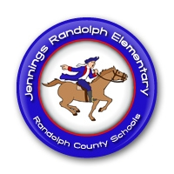
JRES PRE-K
Patriot Newsletter
November 14, 2016
Announcements
- No school on Nov. 21-25th for Thanksgiving break!
- We are lucky to have an Agriculture Education van at JRES this week! We will do some fun activities in it on Wednesday & Thursday afternoon!

This Week’s Activities
We will make pretend birthday cakes out of play-doh & work on counting “candles” on them!
We’ll tell a story about story time & make sure all of our little animals will have a seat!
We will cut straws & lace them to make necklaces & bracelets!
We will practice writing using shaving cream on our tables!

Reminders
- Scholastic orders are due tomorrow!
- American Education Week dress theme-
  - Tues.-PJs
  - Wed.-camo
  - Thurs.-Career Day (dress like what you want to be when you grow up)

Do You Have Questions? Contact Me!
smware@k12.wv.us
304-636-9181

