REACH for Success | 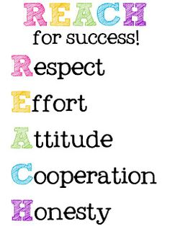
REACH is a whole school positive behavior program at Jennings Randolph Elementary School. Students earn points, recognition and rewards for showing the character traits of: respect, effort, attitude, cooperation, and honesty.

  - Class Dojo 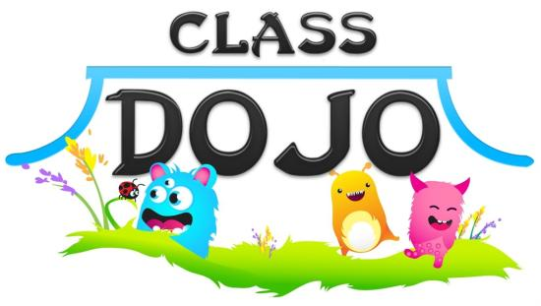
Your child’s teacher will send home more information on how Class Dojo is used to track school and classroom behaviors. You will be able to log on and monitor your child’s behavior.

REACH Expectations
BATHROOM  FLUSH  Flush the toilet  Leave it clean  Use a quiet voice  Soap and water  Head back to class  HALLWAY  Walking feet  Hands to side  Facing forward  2 squares away from wall  Bubble in your mouth/0 voice level  FIRE DRILL  Follow Hallway procedures & Teacher instructions  LUNCHROOM  Follow hallway procedure  Use restroom before lunch  Use good table manners  Once you put your tray down, remain seated  Leave area clean  Raise hand for help  RECESS  Use equipment properly  Stay within bounds  Follow game rules  Show good sportsmanship  Leave sticks on ground  Keep hands to self  Line up when called | ARRIVAL  Walking feet  Come straight into the building  Put coat and backpack in your locker  Report straight to assigned area  DISMISSAL  Listen to announcements and for the bells  Be packed up and ready to go  Follow hallway procedures  ASSEMBLIES  (MEETS)  Make sure to sit on bottom  Eyes watching  Ears listening  Take part  SHHHH!  R  Respect  Respect your teacher, your peers, and the class/school rules at all times.  E  Effort  Pay attention, listen carefully, and always do your best!  A  Attitude  Be positive, kind, helpful, and courteous. Keep negative comments to yourself.  C  Cooperation  Be willing to work with anyone. Share.  H  Honesty  Always tell the truth.

Rewards & Consequences

REWARDS
SUCCESS student for the week
Earn REACH points
SUCCESS Stick- top monthly primary and intermediate class recognized
9 week reward activity

CONSEQUENCES
Verbal reminder
Do not earn REACH points
Note or phone call home
Conference with principal
Attendance Matters
Students must be in school to earn REACH points. Arriving on time and staying until school is dismissed are important parts of school success.

